SCRS/2024/148

**DEVELOPING THE CLIMATE TEST: Performance Metrics of Climate Robustness**

T. R. Carruthers[1]

*SUMMARY*

Operating models were developed from the 2021 stock assessment of bigeye tuna. Four types of projected climate impact were simulated: increasing natural mortality rate, and decreases in recruitment strength, somatic growth and condition factor. Defining a robustness threshold enabled the calculation of a performance metric of climate robustness that was calculated for each type of climate impact for three management procedure (MP) archetypes and two MP derivatives. Shifting the focus away from establishing defensible climate forecasts and towards climate robustness performance metrics, provided information that could support the selection of MPs accounting for climate impacts. It was not necessary to know the exact type of impact or the exact level of forecasted impact to identify an MP that clearly and consistently outperformed the rest in terms of climate robustness.

*KEYWORDS*

*Management strategy evaluation, bigeye tuna, operating model, management procedure, harvest strategy.*

**Introduction**

A review of papers that describe possible climate impacts on fisheries revealed very few examples where defensible forecasts were available (Carruthers 2024). In theory, it is possible to develop an ‘end-to-end’ model that combines sub-models of emissions (e.g., Algieri et al. 2023, Wang et al. 2017), earth systems (Kawamiya et al. 2020), ecosystems (e.g., Beaugrand and Kirby 2018, Lehodey et al. 2010; 2011), behaviour (e.g., Bushnell and Brill 1991, Cayré and Marsac 1993) and physiology (e.g., Gooding et al. 1981, Graham et al. 1989, Checkley et al. 2009). Forecasting fishery impacts would therefore combine a complex series of linked projections that include greenhouse gas emissions (least uncertain), response of climate processes (uncertain), linkages with oceanographic conditions (more uncertain) and the expected impact of those on pelagic communities and individual species (most uncertain). It can be argued that any forecast of climate impacts on fisheries should be seen as firmly hypothetical, and the relative credibility of impact scenarios should be considered highly uncertain.

This large uncertainty over climate impact scenarios poses a problem for the provision of ‘climate ready’ fishery management advice using the contemporary stock assessment and management strategy evaluation (MSE) frameworks. That is because those frameworks rely on the specification of models that represent climate impacts and the frequency (weighting) of those models could strong affect the advice provided. For example, it may not be clear whether there will be small or large future changes in natural survival (natural mortality, M). Advice arising from scenarios with large M changes would likely lead to the provision of strongly differing advice from scenarios with small M changes, yet their relative credibility is not easily evaluated.

Although quantitative forecasts of climate impacts on fisheries may not be available, qualitatively, the way in which climate can impact individual populations is clear. Most papers documenting possible impacts predict changes in recruitment strength (carrying capacity, spawning habitat, larval survival), adult survival (natural mortality rate), somatic growth, spatial distribution (range contraction, catchability) age at maturity and condition factor (fecundity). Additionally, it is generally understood what direction of change in those variables poses a challenge for management procedures: lower recruitment strength, decreased survival, lower somatic growth rate, reduced spatial distribution, older age at maturity and poorer condition factor.

Rather than leaving the investigation of climate resilience stalled in the (perhaps indefinite) wait for scientifically defensible forecasts of climate impacts, this paper proposes an alternative approach. The solution proposed here is to shift the focus from model-based tests of climate robustness in favour of performance metrics of climate robustness. Those metrics are linked to a language of climate robustness to help enable managers to select climate-ready management procedures.

A proof-of-concept is presented here for Atlantic bigeye tuna where metrics of climate robustness were derived from four possible climate impacts on populations.

**Methods**

***Types of Impact***

Climate robustness metrics were developed for four types of impact:

M: increasing natural mortality rate (decreased adult survival)

R: decreasing recruitment strength (carrying capacity, fecundity, larval survival)

K: decreasing somatic growth (von Bertalannfy growth parameter K)

C: decreasing condition factor (weight at age).

For the purposes of this demonstration, these properties were linearly increased/decreased over time. In other climate robustness tests, step changes or variability could also be simulated.

***Operating model***

The operating model was developed from the base case model from the 2021 Stock Synthesis 3 assessment of bigeye tuna (Anon 2021). The model was modified in two ways: (1) the mean current (2019) depletion level was lowered from 1.07 SSBMSY to SSBMSY and (2) a 15% CV on current depletion was assumed, creating depletion scenarios starting both below and above the maximum likelihood estimate from the Base Case assessment (a 90% interval of SSB between 71% and 135% SSBMSY in 2019). These changes were so that management procedures (MPs) would have to navigate situations where the stock was both under and overfished and potentially subject to current overfishing and underfishing (i.e. more uncertain and challenging test of MP performance)

***Defining Robustness Threshold***

In a real management setting, the managers would be required to define what they consider to be a threshold for determining climate robustness. In this demonstration this was defined as a 30% decline in current spawning biomass over 20 years (MPs were tuned to obtain current biomass in 20 years with no climate impact, see below).

The choice of spawning biomass as the variable used to defining robustness was deliberate. Any MSY-based reference points are difficult because they can be highly inconsistent among climate impacts. For example, decreasing recruitment strength impacts estimates of SSB unfished, and SSBMSY but does not impact estimates of FMSY. On the other hand, increasing natural mortality rate both increases FMSY and decreases SSBMSY. In the increasing natural mortality rate scenario the stock could decline strongly while staying above SSBMSY (i.e. it was robust only due to the definition of MSY reference points changing). The use of spawning biomass removes this problem of a moving goal post depending on the type of impact that was simulated.

***Management procedures***

In order to show a diversity of performance outcomes, three index (e.g., CPUE, fishery independent survey) based MP archetypes were tested:

* Index target (*It*) - reduces TAC when index is below the target level, increases TAC when index is above target level (tuned by adjusting the index target level)
* Index ratio (*Ir*) - fishes at a constant multiplier of the recent index level, i.e. a constant F policy (tuned by adjusting the ratio)
* Index slope (*Is*) - aims to achieve a constant slope in the index and reduces TAC when slope is below target and increases TAC when slope is above target (tuned by adjusting target slope).

For each of these MP archetypes, two derivative were specified leading to six MPs in total:

* Max TAC change of 10% (*It_10*, *Ir_10*, *Is_10*)
* Max TAC change of 30% (*It_30*, *Ir_30*, *Is_30*)

In order to make the climate test comparable among MPs, they were all tuned such that they achieved a mean spawning stock biomass in 20 years (2039) that was equal to the current spawning biomass in 2019. In this way, when the various climate impacts are imposed, the difference in spawning biomass after 20 years can be more easily interpreted among MPs.

***Calculating and Labelling Robustness***

For each climate impact, multiple operating models were specified each with an increasing level of impact in the projection years. Closed-loop simulation was used to calculate spawning biomass outcomes for each level of impact and MP (Figure 1, lefthand panels).

Linear interpolation was used to determine the level of impact before the MP crossed the robustness threshold (Figure 1, righthand panels).

Robustness performance was labelled according to the impact and the lowest integer value of change achieved. For example, if an MP was robust up to an 18.92% change in natural mortality rate, that MP would be labelled as *M18 robust*.

**Software and Code**

Operating model specification, MP design, closed-loop simulation and metric calculation was carried out using the openMSE package (Hordyk et al. 2024). The code for completing these analyses is available from the Climate Test repository, github.com/Blue-Matter/ClimateTest.

**Results**

Natural mortality rate was the toughest test of climate resilience (M column, Table 1). This impact type provided the most consistent robustness results among MPs.

The least challenging test of climate robustness and the impact with the highest variability in MP results was condition factor (weight at age, C column, Table 1).

The index target MP archetype was somewhat more climate resilient than the index ratio MP archetype. Both were substantially more climate robust across all impacts than the index slope MP.

The 10% maximum TAC change derivatives always outperformed the 5% maximum TAC change derivatives across all MPs archetypes and climate tests.

The index target MP with 10% maximum TAC change was consistently the climate robust across all climate impact types.

**Discussion**

In this analysis the robustness threshold was chosen arbitrarily in terms of the level of decline and time horizon (30% decline after 20 years) but spawning biomass was selected to deliberately avoid the complicating issue of fishery reference points (e.g., FMSY, SSBMSY) that can change to varying degrees depending on the climate impact. Mean yield is an alternative to spawning biomass that also does not require reference point calculations. To conduct a climate test of MPs for a robustness threshold of say 30% decline in mean yields after 20 years, it would first be necessary to tune MPs to a stable mean yield after 20 years (as was done in this demo for spawning biomass).

Asking managers for the robustness threshold provided top-down information that could be used to identify climate resilient MPs. This type of top-down guidance could provide an opportunity to dramatically streamline MSE development. For example, if managers could instead define ‘ignorable difference’ in MP performance, this could greatly reduce the passing of large amounts of irrelevant information between the technical team and the managers. For example, independently, the technical team cold reject certain MP archetypes within the ‘ignorable difference’ of others, reduce the set of MPs presented to managers to only those spanning greater than the ‘ignorable difference’, and reduce the set of OMs to those spanning at least the ‘ignorable difference’.

**Conclusion**

Shifting the focus away from establishing defensible climate forecasts and towards climate robustness performance metrics, provided information that could support the selection of MPs accounting for climate impacts. It was not necessary to know the exact type of impact (M, R, K or C in this demo) or the exact level of forecasted impact to identify an MP that clearly and consistently outperformed the rest in terms of climate robustness (Index target with 10% maximum TAC change).

**Acknowledgments**

Many thanks to Shana Miller and Grantly Galland for their feedback on earlier concepts for climate robust performance metrics.

This work was funded by The Ocean Foundation.

**References**

Anonymous. 2021. Report of the 2021 bigeye stock assessment meeting. SCRS/2021/011. Collect. Vol. Sci. Pap. ICCAT, 78(2): 335-485.

Algieri, B., Iania, L, Leccadito, A. 2023. Looking ahead: forecasting total energy carbon dioxide emissions. Cleaner Environmental Systems. 9. <https://doi.org/10.1016/j.cesys.2023.100112>

Beaugrand, G., and Kirby, R. R. 2010. Spatial changes in the sensitivity of Atlantic cod to climate-driven effects in the plankton. Clim. Res. 41, 15–19. doi: 10.3354/cr00838

Bushnell, P. G., and Brill, R.W. 1991 Responses of swimming skipjack (Katsuwonus pelamis) and yellowfin (Thunnus albacares) tunas exposed to acute hypoxia, and a model of their cardiorespiratory function. Physiological Zoology. 64, 787–811.

Carruthers, T.R. 2024. Developing the Climate Test: Robustness Trials for Climate-Ready Management Procedures. SCRS/2024/104.

Cayré, P.F., Marsac, F. 1993. Modelling the yellowfin tuna (Thunnus albacares) vertical distribution using sonic tagging results and local environmental parameters. Aquatic Living Resources 6, 1–14.

Checkley, D.M. Jr, Dickson, A.G., Takahashi, I. M., Radich, J.A. et al. 2009. Elevated CO2 enhances growth in young fish. Science. 324, 1683.

Gooding, R.G., Neill, W.H. and Dizon, A.E. 1981. Respiration rates and low-oxygen tolerance limits in skipjack tuna, Katsuwonus pelamis. Fishery Bulletin US 79, 31–47.

Graham, J.B., Lowell, R.W., Lai N.C., Laurs, R.M. 1989. O2 tension, swimming velocity, and thermal effects on the metabolic rate of the Pacific albacore, Thunnus alalunga. Experimental Biology 48, 89–94.

Hordyk, A.R., Huynh Q., Carruthers, T.R.. 2024. OpenMSE: open-source libraries for conducting management strategy evaluation. [www.openMSE.com](http://www.openMSE.com)

Kawamiya, M., Hajima, T., Tachiiri, K. et al. 2020. Two decades of Earth system modeling with an emphasis on Model for Interdisciplinary Research on Climate (MIROC). Prog Earth Planet Sci 7, 64. <https://doi.org/10.1186/s40645-020-00369-5>

Lehodey, P., Hampton, J., Brill, R. W., Nicol, S., Senina, I., Calmettes, B., et al. 2011. “Vulnerability of oceanic fisheries in the tropical Pacific to climate change,” in Vulnerability of tropical pacific fisheries and aquaculture to climate change. Eds. Bell J., Johnson J. E., Hobday A. J. (Noumea: Secretariat of the Pacific Community), 447–506.

Lehodey P, Murtugudde R and Senina I. 2010. Bridging the gap from ocean models to population dynamics of large marine predators: A model of mid-trophic functional groups. Progress in Oceanography 84, 69–74.

Wang, J., Wu, C., Liu, C., Gu, G. 2017. Integrated Assessment models of climate change economics. Springer. Singapore.

**Figures**

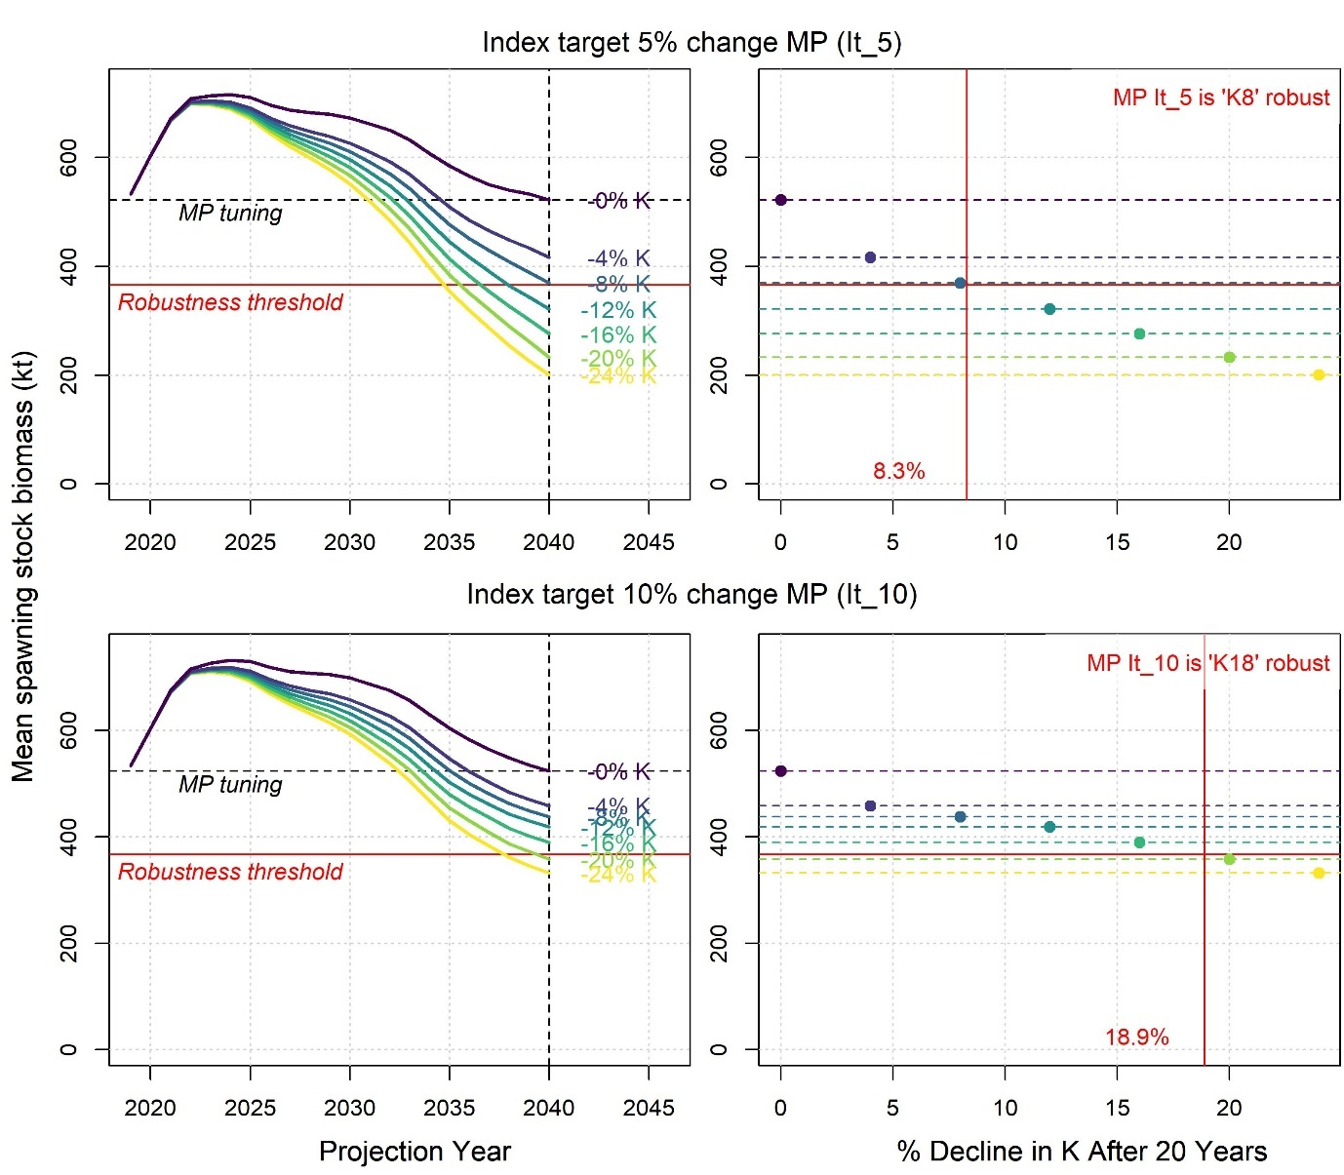Figure 1. Derivation of climate robustness scores based on linear interpolation of MSE projections. The coloured time series lines represent the mean spawning stock biomass outcome under various MSE projections where the somatic growth parameter K declines by various percentages after 20 projection years (between 0 and 24% declines). MP It_10 (index target allowing for 10% changes in TAC between years) (bottom) is more robust (given this definition) in that it takes a much larger decrease in somatic growth (K) to drop below the critical level of spawning biomass (30% decline in biomass from today). Given this definition of robustness, MP It_5 (up to 5% changes in TAC) is ‘K8’ robust, it is only robust to 8% declines in somatic growth compared with 18% for the MP It_10.

**Tables**

Table 1. Climate robustness metrics. Tabulated numbers are the percentage change in each impact before the robustness threshold is reached. Higher percentages that are shaded green represent higher robustness. Shading is scaled per climate test (by column) according to the maximum robustness (highest %) achieved by one of the tabulated MPs. For example, the top lefthand cell is 7%: the Index target MP with up to a 5% change in TAC between years is M7 robust – it can withstand a 7% increase in natural mortality rate before reaching the performance threshold. In this demonstration, the performance threshold is a 30% decline in SSB from current levels after 20 years.

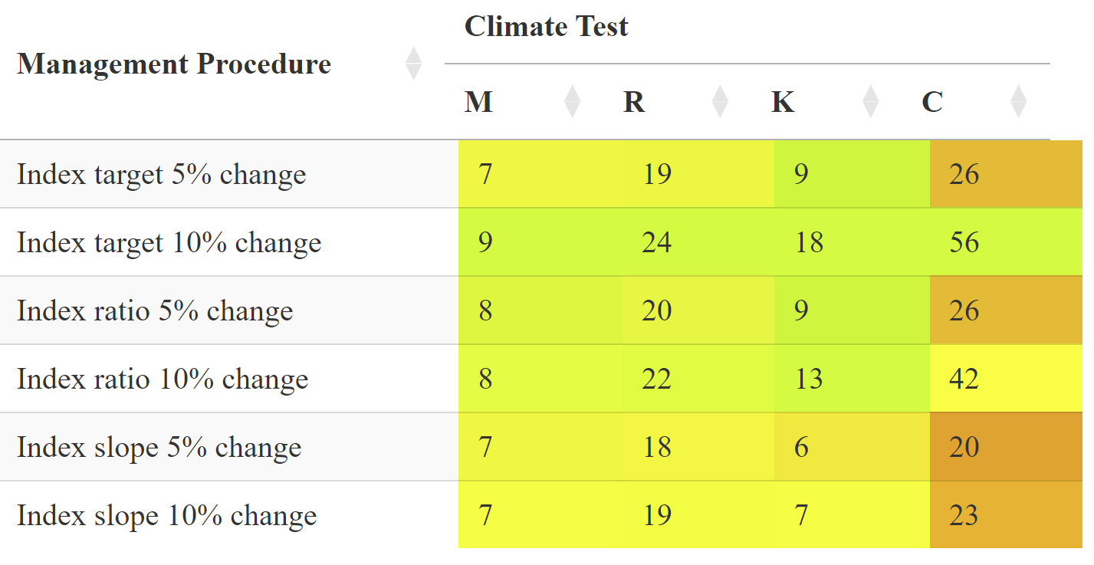

1. Blue Matter Science Ltd. 2150 Bridgman Ave, N. Vancouver. V7P 2T9.